AI Agents

Limitations in LLMs:
- Lack of Real-Time Knowledge: LLMs are trained on data up to a certain point and cannot access real-time or updated information.
For example:
  - ChatGPT (as of 2021 data) won’t know about events in 2023.
  - Asking an LLM about a recently released software tool might result in outdated details.
- No Contextual Memory: LLMs don’t retain memory of past interactions. Each query is treated independently.
- Inability to Perform Actions: LLMs can generate text but cannot perform tasks like booking a flight or sending an email.
- Bias and Inaccuracy: LLMs may produce biased or incorrect outputs based on their training data.
- Limited Understanding: LLMs can't truly understand context like humans. They generate responses based on patterns, not actual comprehension.

What is an AI Agent?
An AI agent is a system that uses artificial intelligence to perform tasks autonomously. It can perceive its environment, make decisions, and take actions to achieve specific goals. AI agents often combine LLMs with other tools, APIs, and decision-making algorithms.

Key Features:
- Autonomy: Can operate without constant human intervention.
- Adaptability: Learns and improves over time.
- Goal-Oriented: Designed to achieve specific objectives.
Examples:
A customer support AI agent can answer queries, resolve issues, and escalate problems to human agents if needed.
A chatbot that not only responds to user queries but also books a ticket for a flight, considering available options, user preferences, and payment details.

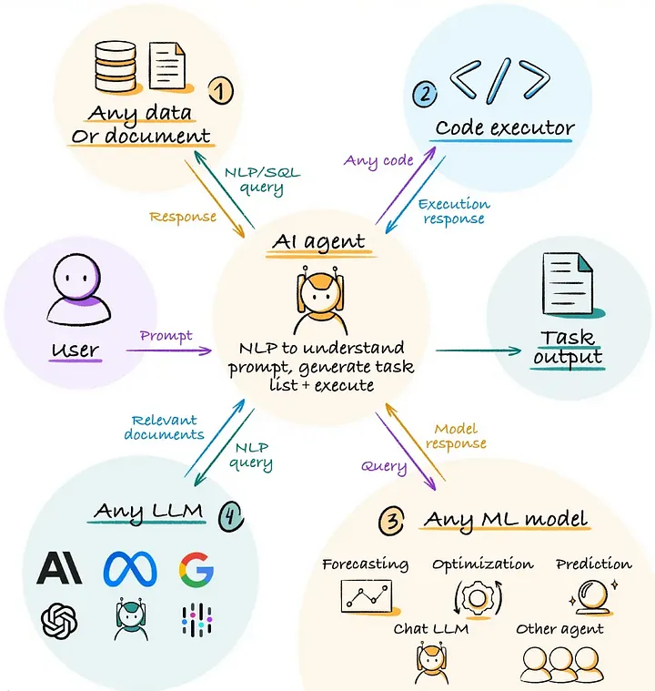

How AI Agents Overcome Limitations of LLM:
- Integration with Tools: AI agents can connect to APIs, databases, or tools to perform actions (e.g., booking a ticket or fetching real-time data).
- Memory and Context: AI agents can maintain context across interactions by storing conversation history or using external memory systems.
- Real-Time Data Access: AI agents can fetch live data from the internet or other sources to provide up-to-date information.
- Task Automation: They can perform automated tasks, unlike LLMs which only provide text responses.They can execute tasks like sending emails, updating spreadsheets, or controlling smart devices.

Example: An AI agent can use an LLM to understand a user’s request ("Book a flight to New York") and then connect to a travel API to perform the booking.

Difference Between LLM and AI Agent
LLM :
- Role: LLMs can generate test cases, write code, or document test results based on natural language inputs.
- Limitation: They cannot execute tests or interact with software systems directly.
- Example: An LLM can suggest test scenarios for a login feature but cannot run the tests.
AI Agent:
- Role: AI agents can automate the entire testing process, from generating test cases to executing them and reporting bugs.
- Capabilities: They can interact with software, simulate user actions, and integrate with CI/CD pipelines.
- Example: An AI agent can automatically test a web application by clicking buttons, filling forms, and validating outputs.

Criteria | LLM in Software Testing | AI Agent in Software Testing
Purpose | Assist in creating test cases, writing test plans, generating data | Execute tests, analyze results, identify issues, automate decisions
Context Understanding | Limited to text-based context | Comprehensive understanding of scenarios
Decision-Making | No decision-making capability | Can make decisions based on rules and learning
Example | Generating test case ideas from requirements | Automating regression testing and analyzing test results

